Chapter 2, Problem 58.

The 60 W light bulb in Fig. 2.122 is rated at 120 volts. Calculate the value of V_{s} to make the light bulb operate at its rated conditions.

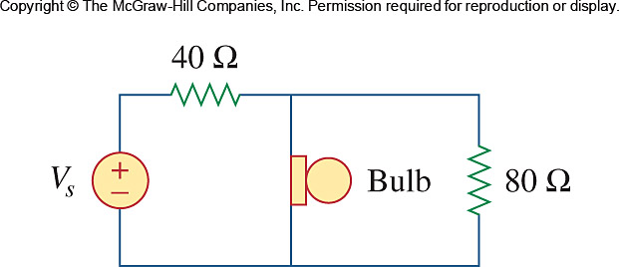

Figure 2.112
For Prob. 2.58.

